**Idle Behaviour: How to Navigate and Understand IdleNotifierPlugin**

IdleNotifier is a plugin that pings the user (player) immediately when their character becomes idle, or when certain crucial stats reach a defined threshold. The purpose of IdleNotifier is meant for players to re-interact with the game when they receive a notification, so that their character can continue doing what they are doing. Runescape is a subscription based MMO(Massively Multiplayer Online) game and thus idleness is important for the player because idleness can leave a player wasting precious subscription time. A plugin that maximizes time efficiency is important, so the IdleNotifierPlugin is a crucial plugin.

For more information on what the IdleNotifier does:

<https://github.com/runelite/runelite/wiki/Idle-Notifier>

The key files to the IdleNotifierPlugin are IdleNotifierPlugin.java and IdleNotifierConfig.java, both of which reside in the directory runelite-client/src/main/java/net/runelite/client/plugins/idlenotifier/. The important function to inspect is IdleNotifierPlugin::onGameTick(). Two state variables in IdleNotifierPlugin called **notifier** and **config** are injected by the Notifier and IdleNotifierConfig class from runelite-client/src/main/java/net/runelite/client/plugins/idlenotifier/IdleNotifierConfig.java and runelite-client/src/main/java/net/runelite/client/Notifier.java, respectively. These two variables are significant because they are used in onGameTick(), which is a method that checks if the animation state has changed to idle via config.animationIdle() (or any other idle method that returns a boolean for that matter) and subsequently calls notifier.notify(). A popup notification, which depends on the operating system running the client, shows up to the user with the corresponding notification message.

*Injection for the notifier and config on lines 80 and 86 respectively:*

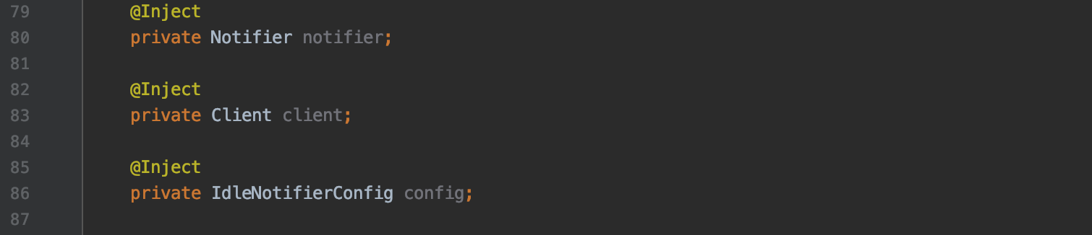

*onGameTick() calling methods that checks for idleness on the config variable and subsequently calling notify() on notifier on lines 414-416 for example:*

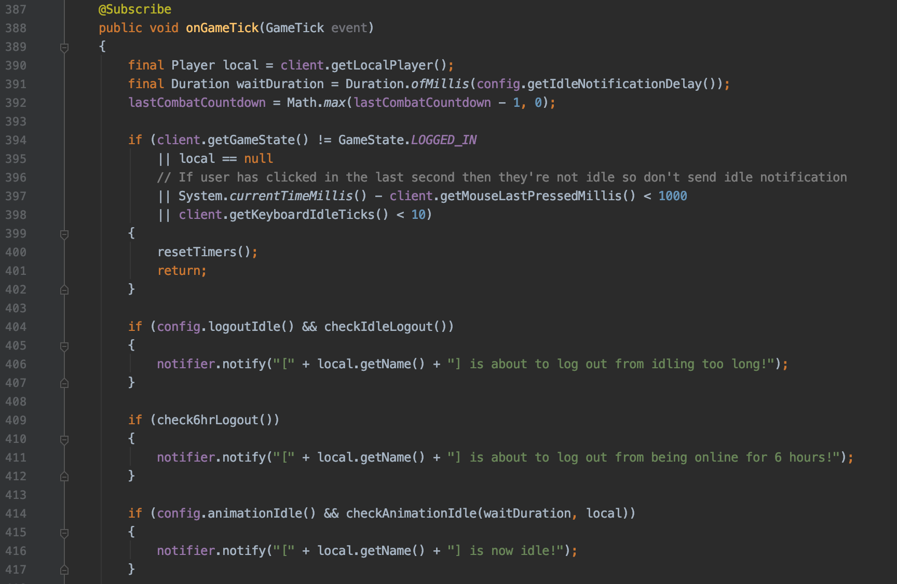

Within the Notifier class and within the notify() method, sendNotification is called which checks against the OSType so that the client knows what kind of notification to send to the user based on the current platform.

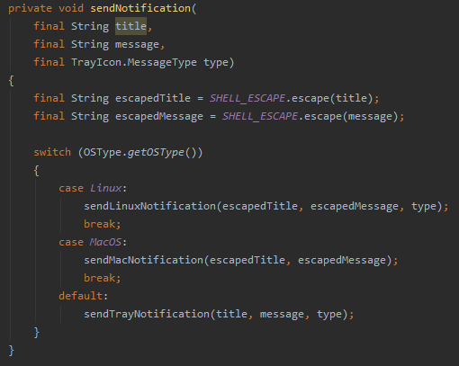

Call Graph for IdleNotifierPlugin generated from onGameTicks():

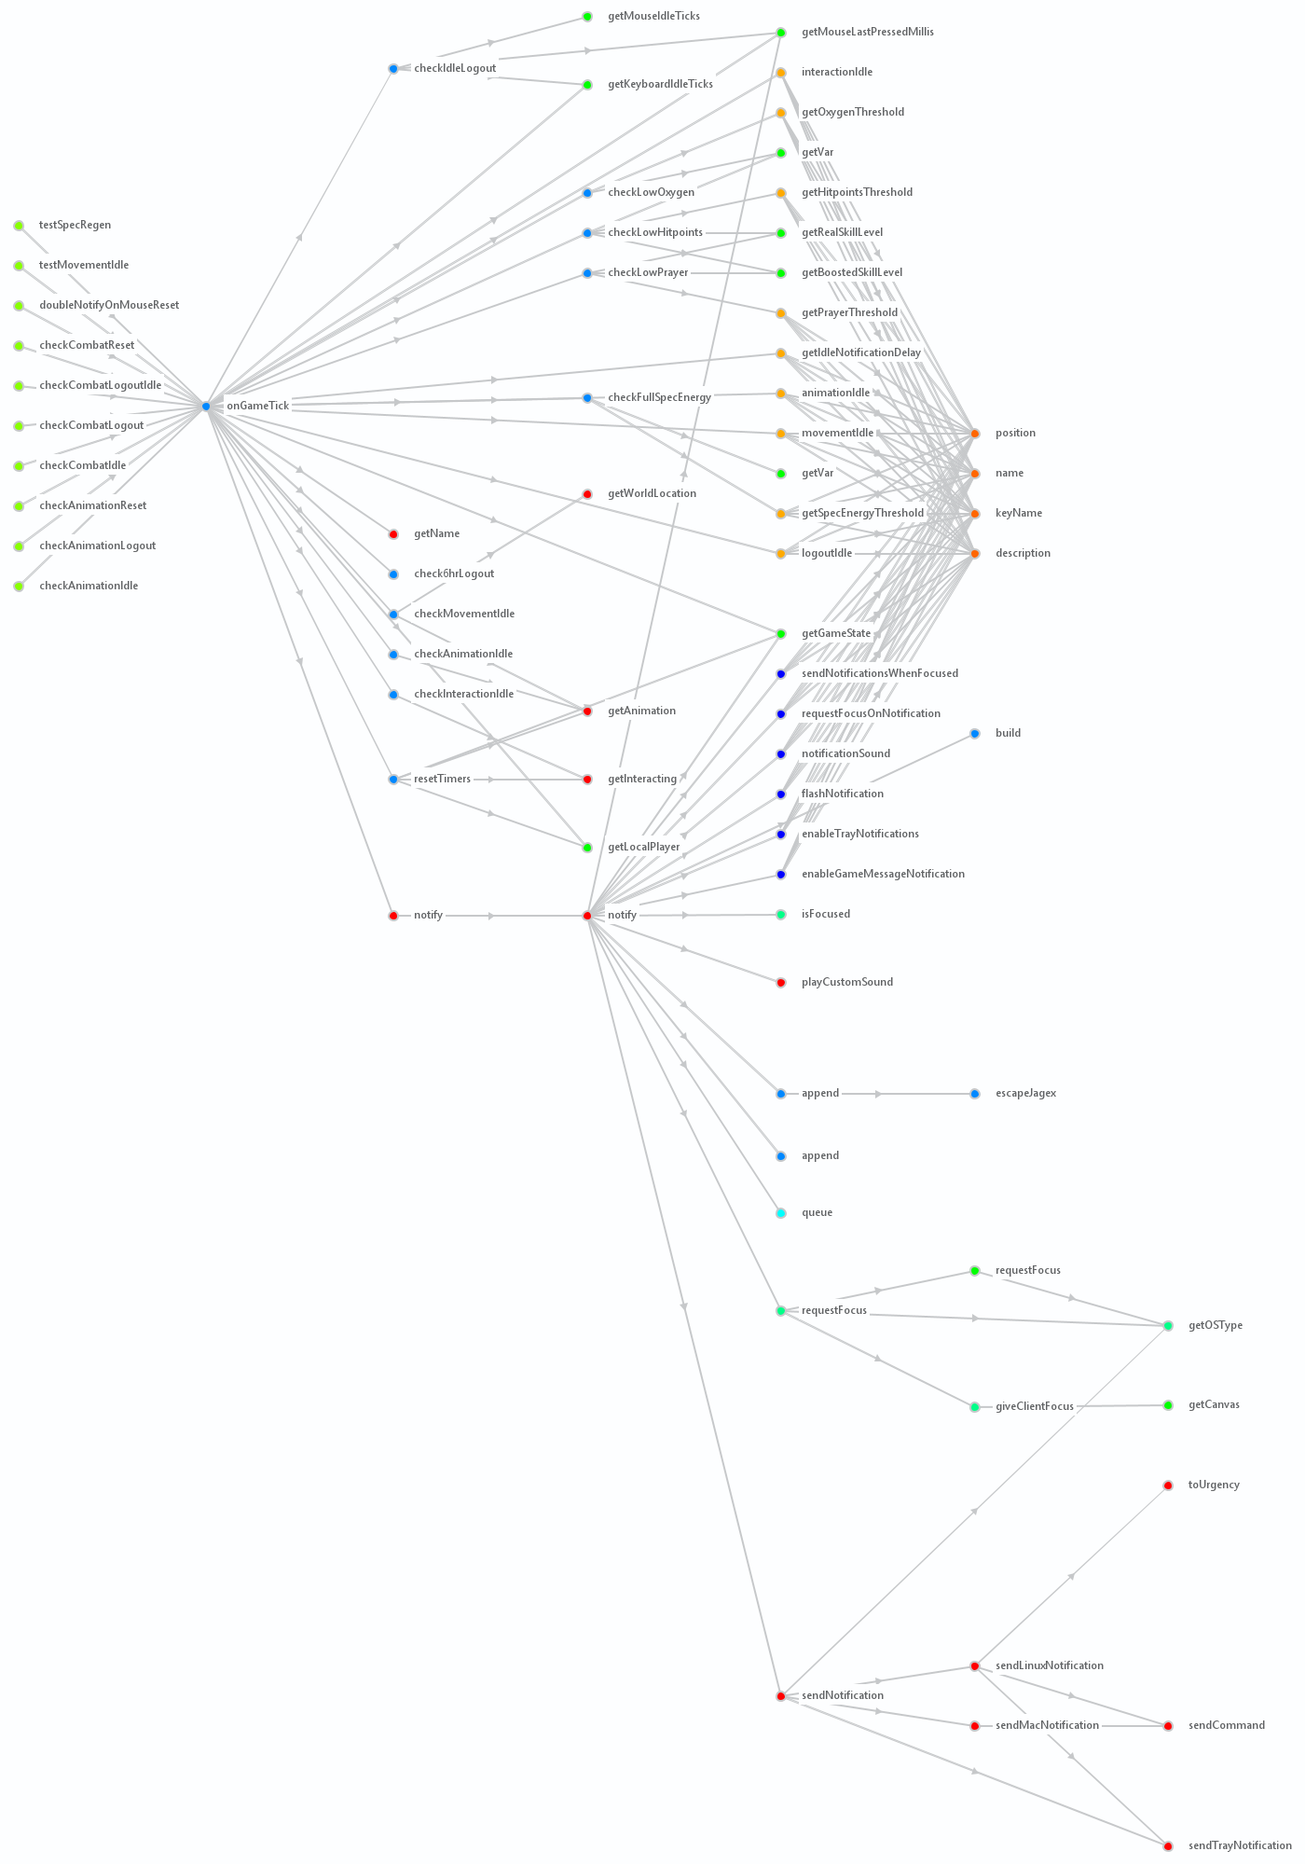

Sequence Diagram(truncated) for IdleNotifierPlugin generated from onGameTicks():

